**UNIT I CARDIAC EQUIPMENT**

**Electrocardiograph**

An electrocardiograph or ECG is a test used to measure the electrical activity of the heart. The electrical activity of the heart causes the heart muscles to contract that result in the pumping of the heart. The ECG is in the form of spikes and dips known as waves. The wave pattern helps in assessing the rate and rhythm of our heartbeat.

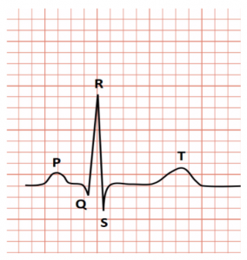

P to T in the graph represents a specific activity of the heart. Let’s break it down.

* The P wave is the electrical excitation of the atria, or depolarization, initiating atrial contraction.
* The QRS complex is the depolarization of ventricles, initiating ventricular contraction. Marking the beginning of the systole.
* T wave means the return of ventricles to the normal state (repolarization). Marking the end of the systole.

By counting the number of QRS complexes we can evaluate the heartbeat rate of the patient. Any deviations in this shape results in heart diseases or an abnormal heart rhythm which can either be slow, irregular or very fast heartbeats.

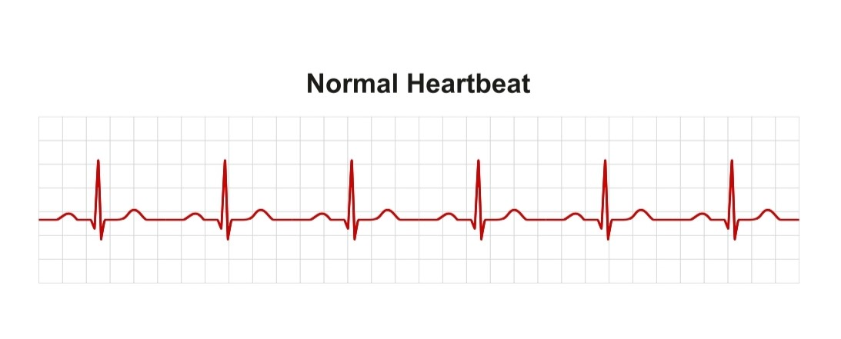

Heart rate: A normal resting heart rate for adults is between 60 and 100 beats per minute.

Rhythm: A normal ECG rhythm is described as sinus rhythm (regular) and without significant pauses or extra beats.

An abnormal ECG result could mean anything from an abnormal heart rate, irregular rhythm, abnormal waveforms or abnormal intervals:

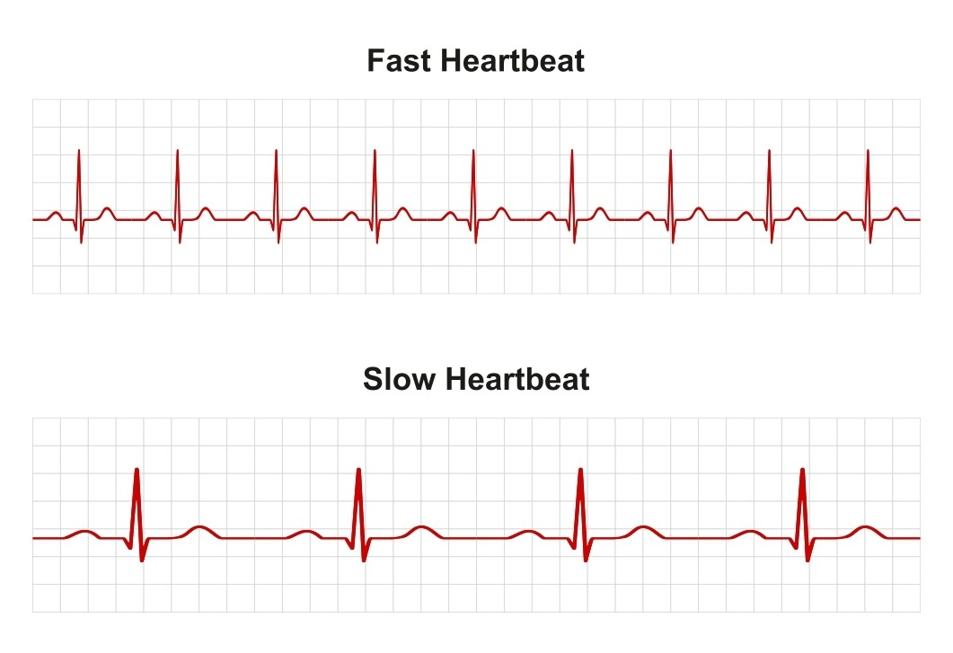

Abnormal heart rate: A heart rate that is faster or slower than what is considered normal could be a sign of atrial fibrillation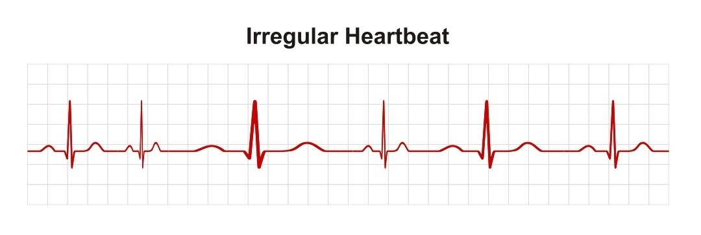

**Holter Monitor**

The Holter monitor is a type of portable electrocardiogram (ECG). It records the electrical activity of the heart continuously over 24 hours or longer while you are away from the doctor's office. A standard or "resting" ECG is one of the simplest and fastest tests used to evaluate the heart.

Natural electrical impulses coordinate contractions of the different parts of the heart. This keeps blood flowing the way it should. An ECG records these impulses to show how fast the heart is beating, the rhythm of the heart beats (steady or irregular), and the strength and timing of the electrical impulses. Changes in an ECG can be a sign of many heart-related conditions.

Your healthcare provider may request a Holter monitor ECG if you have symptoms, such as dizziness, fainting, low blood pressure, ongoing fatigue (tiredness), and palpitations and a resting ECG doesn’t show a clear cause. You wear the same kind of ECG electrode patches on your chest, and the electrodes are connected by wires to a small, portable recording device.

**Phonocardiography**

Phonocardiography, diagnostic technique that creates a graphic record, or phonocardiogram, of the sounds and murmurs produced by the contracting heart, including its valves and associated great vessels. The phonocardiogram is obtained either with a chest microphone or with a miniature sensor in the tip of a small tubular instrument that is introduced via the blood vessels into one of the heart chambers.

Heart sounds result from vibrations created by the closure of the heart valves. There are at least two; the first (S1) is produced when the atrioventricular valves (tricuspid and mitral) close at the beginning of systole and the second (S2) when the aortic valve and pulmonary valve (semilunar valves) close at the end of systole.

**ECG machine maintenance and troubleshooting**

ECG machines should be regularly cleaned and maintained. A few simple steps will keep machines running well and lasting a long time.

* After daily use, electrodes should be cleaned. If copper alloy electrodes become rusted, fine sandpaper will remove the rust after soaking overnight in a saline solution. Silver-plated electrodes can be gently wiped clean with water to avoid damaging the surface.
* Lead wires can break or be easily damaged near connections. Avoid pulling or twisting with too much force. Check connections often.
* Battery operated ECG machines should be charged daily.
* Avoid heat, moisture, dust or shock. Store with dust cover if possible.
* Open the device every six months and remove dust with a can of compressed air. If used in high humidity environments, circuit boards can be dried with a household blow dryer set on low or no heat.
* Follow manufacturer instructions regarding service.
* Instructions for how to calibrate ECG machines will be provided by the manufacturer. Regular calibration is essential to ensure accurate readings.

Troubleshooting ECG artifact

Hearing up to 700 clinical alarms per patient day1 can be exhausting. Trying to interpret and troubleshoot ECG traces can be equally as tiring. 3M can help you identify the different sources of ECG artifact and help you troubleshoot poor trace quality.

Factors that can impact trace quality

* Skin impedance - The skin’s opposition or resistance to electrical signals flowing through it. This resistance of the skin, can impede the transmission of the electrical signal from the heart, to the sensing element in the electrode.
* Muscle movement - Patient movement can create artifact on an ECG trace, which can make it more difficult for the monitor to correctly identify alarms.
* Electrical continuity - Any break in the ECG signal path will stop the ECG signal from reaching the monitor. A cable or leadwire that isn't fully plugged in can also stop the ECG signal from reaching the monitor.
* Electrodes - Using fresh, high quality electrodes ensures good contact with the skin, providing reliable adhesion and conduction.
* Cabling - Broken cables or leadwires can prevent the ECG signal from reaching the monitor.
* Interference - Unwanted artifact on the ECG trace from nearby interfering sources such as power cords, infusion pumps, ventilators, etc. can easily be reduced by abrading the patient's skin.
* Equipment - Your monitor settings can have significant impact on the trace quality and alarm accuracy.

**Pacemaker**

A pacemaker is a device used to control an irregular heart rhythm. A pacemaker has flexible wires called leads. The wires are placed in one or more chambers of the heart. They deliver electrical signals to fix the heart rate. Some newer pacemakers don't need wires.

A pacemaker is used to control or increase the heartbeat. It stimulates the heart as needed to keep it beating regularly.

The heart's electrical system typically controls the heartbeat. Electrical signals, called impulses, move through the heart chambers. They tell the heart when to beat.

Changes in heart signaling may happen if the heart muscle is damaged. Heart signaling problems also may be caused by changes in genes before birth or by using certain medicines.

You may need a pacemaker if:

* You have a slow or irregular heartbeat that lasts for a long time, also called chronic.
* You have heart failure.

A pacemaker only works when it senses trouble with the heartbeat. For example, if the heart beats too slowly, the pacemaker sends electrical signals to correct the beat. Some pacemakers can increase the heartbeat as needed, such as during exercise.

A pacemaker may have two parts:

* **Pulse generator.** This small metal box has a battery and electrical parts. It controls the rate of electrical signals sent to the heart.
* **Leads.** These are flexible, insulated wires. One to three wires are placed in one or more of the heart's chambers. The wires send the electrical signals needed to correct an irregular heartbeat. Some newer pacemakers don't need leads. These devices are called leadless pacemakers.

**Risks**

Possible complications of a pacemaker device or its surgery may include:

* Infection near the site in the heart where the device is placed.
* Swelling, bruising or bleeding, especially if you take blood thinners.
* Blood clots near where the device is placed.
* Damage to blood vessels or nerves.
* Collapsed lung.
* Blood in the space between the lung and the chest wall.
* Moving or shifting of the device or leads, which could cause a hole in the heart. This complication is rare.

Internal Pacemaker

Internal pacemakers are devices that can be placed in your body, usually by surgery, to support the electrical system in your heart. They can stabilize abnormal heart rhythms and prevent problems that can disrupt or endanger your life.

Permanent pacemakers are built into molded epoxy- silicone rubber packages, although some recent models include an outer titanium shield that guards against interference from radio frequency fields.

The device is implanted subcutaneously in either the abdomen or a region just below the collarbone.

Some implantable pacemaker have a single fixed rate, usually about 70 BPM, while others are dual-rate models. The latter type can be programmed from outside the patient's body using a magnet or induction coil. Still others are programmable from 30 to 150 BPM.

* The principal power source for implantable pacemaker is the lithium iodine cell.
* Mercury pacemaker batteries are able to operate for as long as 4 to 5 years, but its usual to find service periods of 1.5 to 3 years.
* X-ray examination shorten the battery life.
* Pulse rate drops with decreased battery voltage.
* Sometimes the heart rate of patient serve as the early indicator of battery failure.
* Some work has been done on the nuclear power source for pacemaker.

External pacemakers

External pacemakers are a temporary measure used following open-heart surgery for certain problems experienced by some myocardial infarction patients, and for patients who are to be evaluated for surgical implantation of a permanent mode.

External models are usually adjustable from 50 to 150 BPM and produce fixed-duration, short duty cycle pulses (is., 1.5 to 2.0 ms).

The peak current amplitude is adjustable from 100 μA to 20 mA.

Types:

▸ Transvenous pacemaker

Leads are threaded transvenously to the chambers and attached to the power source

▸ Epicardial pacing

The pacing leads are attached to the epicardium during heart surgery

▸ Transcutaneous pacemaker

Noninvasive, power source is attached to large electrodes placed over the anterior and posterior chest

**Defibrillator**

A defibrillator is a device that gives a high energy electric shock to the heart of someone who is in cardiac arrest. This high energy shock is called defibrillation, and it's an essential part in trying to save the life of someone who's in cardiac arrest.

Types of Defibrillators

* AC defibrillators
* DC defibrillators

**AC Defibrillators**

An AC defibrillator is the oldest and simplest type. The construction of AC defibrillator is such that appropriate values are available for internal and external defibrillation. In AC defibrillation, a shock of 50 Hz a.c frequency is applied to the chest for a time of 0.25 to 1 second through electrodes. The procedure of applying electric shock to resynchronize heart is known as Countershock.

Defibrillation continues until patient responds to the treatment. An AC defibrillator consists of a step-up transformer with primary and secondary winding, and two switches. A.C supply is given through switches and fuse to primary winding of the transformer. The timing circuit is connected with switch, which is used to preset the time for the defibrillator to deliver shock to the patient.

A resistive and a simple capacitor network or monostable multivibrator forms the timing circuit. It is triggered with a foot switch or a push button switch. Various tapping are available along the secondary winding. They are connected to the electrodes that delivers electric shock to the heart of the patient. Voltage value ranging between 250 V to 750 V is applied for AC external defibrillation.

For safety reasons, secondary coil should be isolated from earth to avoid shock. For internal fibrillation voltage values between 60 V to 250 V is applied. To produce uniform and simultaneous contraction of heart muscles large currents are used for external defibrillation. However, this results in skin burn under electrodes and violent contraction of heart muscles. It also results in atrium fibrillation and stops ventricular fibrillation.

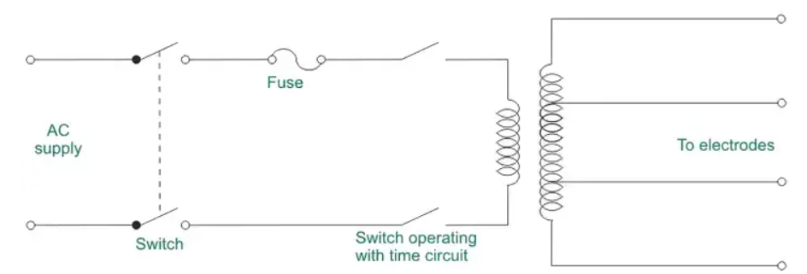

**DC Defibrillators**

DC defibrillator does not produce side effects and produces normal heartbeat. Ventricular fibrillation is avoided when high-energy shock is passed through discharging capacitor that is exposed to heart or chest of the patient. DC defibrillator consists of auto transformer T1 that acts as primary of the high voltage transformer T2.

A diode rectifier rectifies the output voltage from T2. It is connected to vacuum type-high voltage over switch. At position A, switch is connected to one end of the capacitor. When connected in this position capacitor charges to a voltage. A foot switch present on the handle of the electrode is used to deliver shock to the patient.

Now the high voltage switch changes it position to B that makes the capacitor to discharge to the heart through electrodes. To slow down the discharge from the capacitor an inductor L is placed in one of the electrode lead. This L induces a counter voltage that reduces the capacitor discharge value.

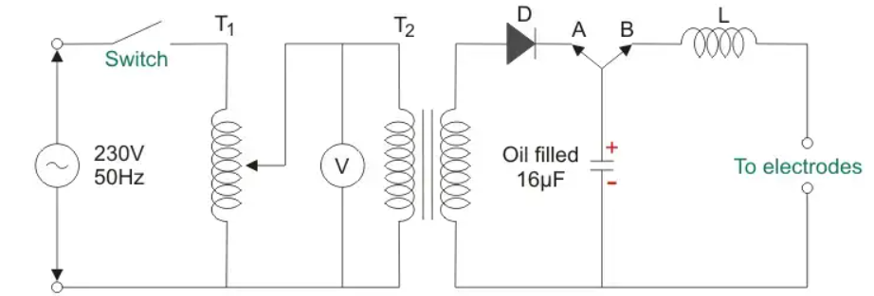

**Internal Defibrillator**

* Manual internal defibrillator

The manual internal defibrillators use internal paddles to send the electric shock directly to the heart. They are used on open chests, so they are only common in the operating room. It was invented after 1959.

* Implantable cardioverter-defibrillator

Another name for this is automatic internal cardiac defibrillator (AICD). They constantly monitor the patient’s heart, similar to a pacemaker, and can detect ventricular fibrillation, ventricular tachycardia, supraventricular tachycardia, and atrial fibrillation. When an abnormal rhythm is detected, the device automatically determines the voltage of the shock to restore cardiac function.

**External Defibrillator**

* Manual external defibrillator

These defibrillators require more experience and training to effectively handle them. Hence, they are only common in hospitals and a few ambulances where capable hands are present. In conjuntion with an ECG, the trained provider determines the cardiac rhythm and then manually determines the voltage and timing of the shock—through external paddles—to the patient’s chest.

* Automated external defibrillator

These are defibrillators that use computer technology, thereby making it easy to analyze the heart’s rhythm and effectively determine if the rhythm is shockable. They can be found in medical facilities, government offices, airports, hotels, sports stadiums, and schools.

* Wearable cardiac defibrillator

Further research was done on the AICD to bring forth the wearable cardiac defibrillator, which is a portable external defibrillator generally indicated for patients who are not in an immediate need for an AICD. This device is capable of monitoring the patient 24-hours-a-day. It is only functional when it is worn and sends a shock to the heart whenever it is needed. However, it is scarce in the market today.

**Defibrillator protection circuit**

This ECG defibrillator protection circuitry involves trade-offs between how well the amplifiers are protected and the frequency response necessary for the ECG to function properly. The capacitance of the protection devices is critical to preserve the wanted heart frequency response.

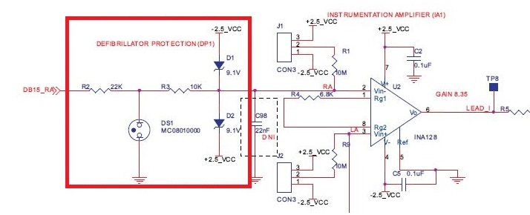

**Cardiac ablation catheter**

Catheter ablation is a minimally invasive treatment for fast heartbeats. A catheter is a thin tube inserted through a blood vessel to your heart. Catheter ablation is one type of heart ablation procedure used to treat abnormal heart rhythms (arrhythmias). Ablation is a technique used to strategically destroy abnormal tissue and restore proper function to your heart.

A cardiologist (a doctor who specializes in treating heart conditions) performs catheter ablation. The procedure uses hot or cold energy to create scars in your heart tissue where the arrhythmia is occurring. The scars help block abnormal electrical impulses and prevent abnormal rhythms.

The scars only destroy tissue involved with faulty heart patterns. They don’t cause any residual pain or create problems with your heart’s function.

Also known as a cardiac ablation or radiofrequency ablation Not everyone with a heart arrhythmia needs a catheter ablation. It’s usually recommended for people with arrhythmias that can’t be controlled by medication or with certain types of arrhythmia from the heart’s upper chambers, called the atria.